Machine learning Lab Observation
ITA0614
Experiment 5
Write a program for Implementation of K-Nearest Neighbours (K-NN) in Python
Name : HARIHARAN GB
Reg.No : 192412390
Problem 1 : Fruit Classification
Aim
To implement the K-Nearest Neighbours algorithm from scratch in Python to classify a fruit as Apple, Orange or Banana from its weight and length, and to predict the class of new fruits.
Algorithm
- Load the data set and scale the features (standardisation or min-max) so that every feature contributes equally to the distance.
- Choose the number of neighbours K (a small odd number is preferred for classification).
- For a new sample x, compute the Euclidean distance d(x, t) = sqrt( sum of (x_i - t_i)^2 ) to every training sample t.
- Sort the distances in ascending order and select the K training samples with the smallest distances (the K nearest neighbours).
- Classification: count the class labels of the K neighbours and assign the class with the majority vote (the vote fraction gives the probability).
- Repeat steps 3 to 5 for every test sample and measure the performance (accuracy) for different values of K, using a test set or leave-one-out validation.
- Select the K that gives the best performance and use it to predict the output for a new sample.
Program:
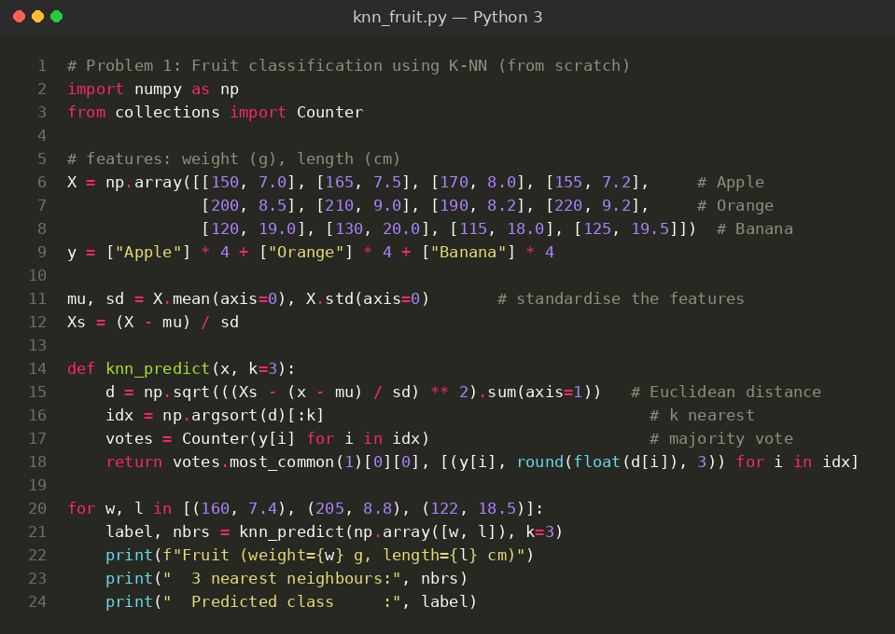
Input
Fruit data set: 12 training examples with 2 features (weight in grams, length in cm) and 3 classes. Features are standardised and K = 3 is used. New fruits tested: (160 g, 7.4 cm), (205 g, 8.8 cm) and (122 g, 18.5 cm).
Weight (g) | Length (cm) | Fruit
150 | 7.0 | Apple
165 | 7.5 | Apple
170 | 8.0 | Apple
155 | 7.2 | Apple
200 | 8.5 | Orange
210 | 9.0 | Orange
190 | 8.2 | Orange
220 | 9.2 | Orange
120 | 19.0 | Banana
130 | 20.0 | Banana
115 | 18.0 | Banana
125 | 19.5 | Banana
Output
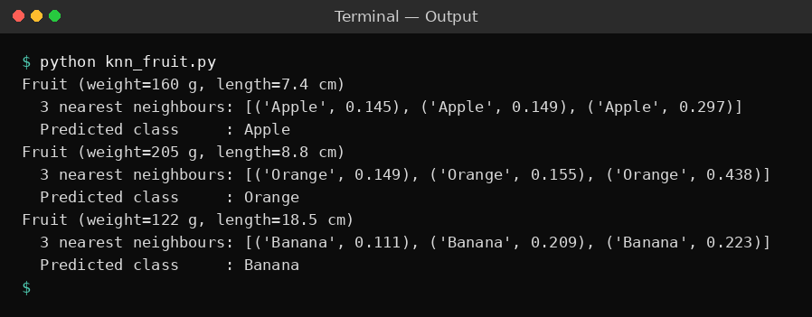
Result
For each new fruit all three nearest neighbours belong to the same class, so the majority vote is unanimous. The fruit (160 g, 7.4 cm) is classified as Apple (nearest distance 0.145), the fruit (205 g, 8.8 cm) as Orange (0.149) and the fruit (122 g, 18.5 cm) as Banana (0.111). All three predictions are correct.
Problem 2: Iris Flower Classification
Aim
To implement K-NN to classify Iris flowers into three species, and to find the best value of K by comparing the test accuracy for K = 1, 3, 5, 7, 9 and 11.
Algorithm
- Load the data set and scale the features (standardisation or min-max) so that every feature contributes equally to the distance.
- Choose the number of neighbours K (a small odd number is preferred for classification).
- For a new sample x, compute the Euclidean distance d(x, t) = sqrt( sum of (x_i - t_i)^2 ) to every training sample t.
- Sort the distances in ascending order and select the K training samples with the smallest distances (the K nearest neighbours).
- Classification: count the class labels of the K neighbours and assign the class with the majority vote (the vote fraction gives the probability).
- Repeat steps 3 to 5 for every test sample and measure the performance (accuracy) for different values of K, using a test set or leave-one-out validation.
- Select the K that gives the best performance and use it to predict the output for a new sample.
Program:
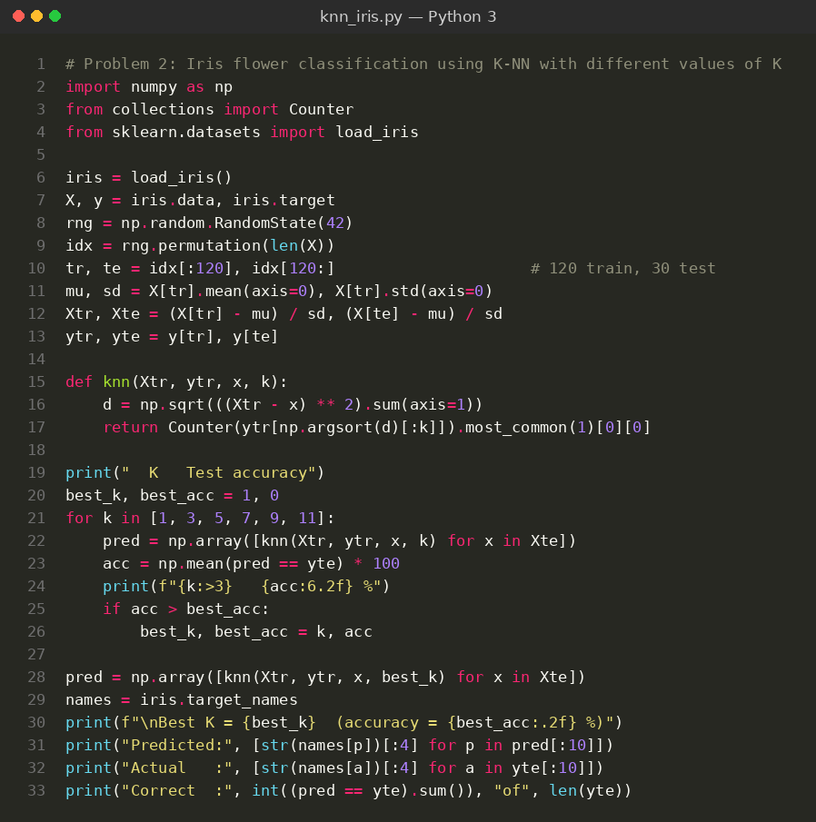
Input
Iris data set (loaded from scikit-learn): 150 samples, 4 features (sepal length, sepal width, petal length, petal width in cm) and 3 classes (setosa, versicolor, virginica). Features are standardised; 120 samples are used for training and 30 for testing. A few sample rows are shown below.
Sepal Length | Sepal Width | Petal Length | Petal Width | Class
5.1 | 3.5 | 1.4 | 0.2 | setosa
4.9 | 3.0 | 1.4 | 0.2 | setosa
7.0 | 3.2 | 4.7 | 1.4 | versicolor
6.4 | 3.2 | 4.5 | 1.5 | versicolor
6.3 | 3.3 | 6.0 | 2.5 | virginica
5.8 | 2.7 | 5.1 | 1.9 | virginica
Output
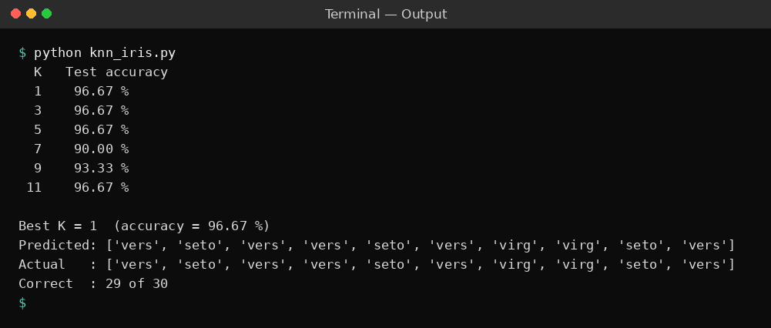
Result
The test accuracy was 96.67 % for K = 1, 3, 5 and 11, 90.00 % for K = 7 and 93.33 % for K = 9. The best value K = 1 classified 29 of the 30 test flowers correctly, and the first ten predicted species are the same as the actual species.
Problem 3: Student Pass / Fail Prediction
Aim
To use K-NN to predict whether a student passes or fails from the study hours and attendance, to choose K using leave-one-out accuracy, and to test it on new students.
Algorithm
- Load the data set and scale the features (standardisation or min-max) so that every feature contributes equally to the distance.
- Choose the number of neighbours K (a small odd number is preferred for classification).
- For a new sample x, compute the Euclidean distance d(x, t) = sqrt( sum of (x_i - t_i)^2 ) to every training sample t.
- Sort the distances in ascending order and select the K training samples with the smallest distances (the K nearest neighbours).
- Classification: count the class labels of the K neighbours and assign the class with the majority vote (the vote fraction gives the probability).
- Repeat steps 3 to 5 for every test sample and measure the performance (accuracy) for different values of K, using a test set or leave-one-out validation.
- Select the K that gives the best performance and use it to predict the output for a new sample.
Program:
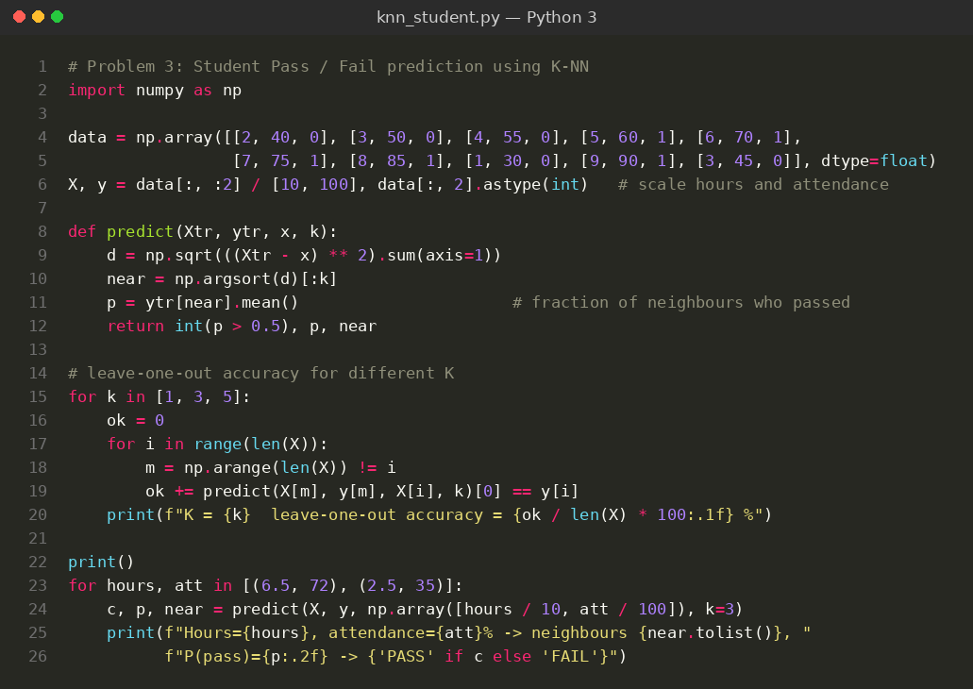
Input
Student data set: 10 training examples with 2 inputs (study hours per day, attendance %) and the target Result (1 = Pass, 0 = Fail). Hours are divided by 10 and attendance by 100 before the distances are found. K = 3 is used for the new students: (6.5 h, 72 %) and (2.5 h, 35 %).
Study Hours | Attendance % | Result
2 | 40 | 0 (Fail)
3 | 50 | 0 (Fail)
4 | 55 | 0 (Fail)
5 | 60 | 1 (Pass)
6 | 70 | 1 (Pass)
7 | 75 | 1 (Pass)
8 | 85 | 1 (Pass)
1 | 30 | 0 (Fail)
9 | 90 | 1 (Pass)
3 | 45 | 0 (Fail)
Output
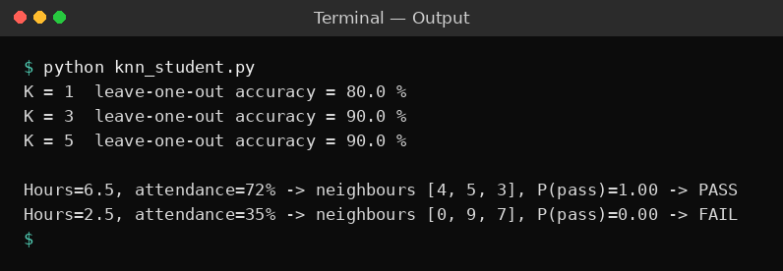
Result
The leave-one-out accuracy was 80 % for K = 1 and 90 % for K = 3 and K = 5, so K = 3 was used. The student with 6.5 hours and 72 % attendance is predicted PASS (probability 1.00, all three neighbours passed) and the student with 2.5 hours and 35 % attendance is predicted FAIL (probability 0.00).
Problem 4: House Price Prediction (K-NN Regression)
Aim
To implement K-NN regression that predicts the price of a house (in lakhs) from its area, number of bedrooms and age, choosing K with the leave-one-out mean absolute error.
Algorithm
- Load the data set and scale the features (standardisation or min-max) so that every feature contributes equally to the distance.
- Choose the number of neighbours K (a small odd number is preferred for classification).
- For a new sample x, compute the Euclidean distance d(x, t) = sqrt( sum of (x_i - t_i)^2 ) to every training sample t.
- Sort the distances in ascending order and select the K training samples with the smallest distances (the K nearest neighbours).
- Regression: take the mean of the target values of the K neighbours as the predicted value.
- Repeat steps 3 to 5 for every sample and measure the mean absolute error (MAE) for different values of K using leave-one-out validation.
- Select the K that gives the best performance and use it to predict the output for a new sample.
Program:
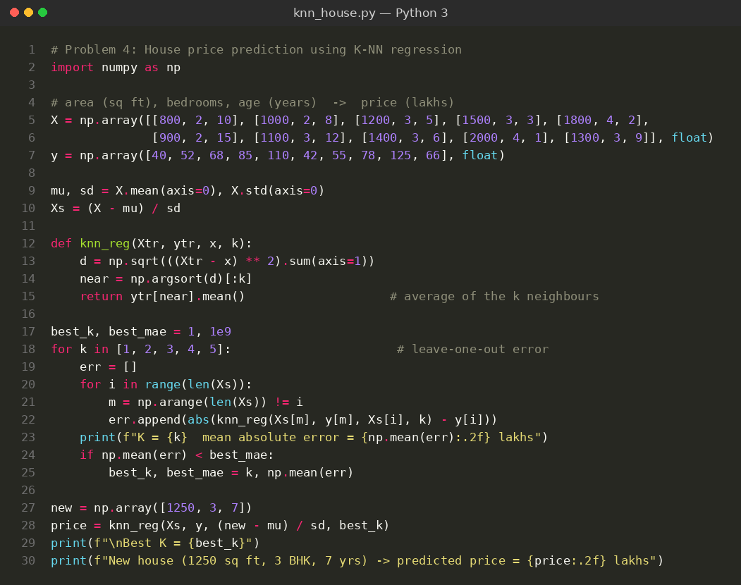
Input
House data set: 10 training examples with 3 inputs (area in sq ft, bedrooms, age in years) and the target price in lakhs. Inputs are standardised and K is chosen from 1 to 5. The new house tested has 1250 sq ft, 3 bedrooms and is 7 years old.
Area (sq ft) | Bedrooms | Age (years) | Price (lakhs)
800 | 2 | 10 | 40
1000 | 2 | 8 | 52
1200 | 3 | 5 | 68
1500 | 3 | 3 | 85
1800 | 4 | 2 | 110
900 | 2 | 15 | 42
1100 | 3 | 12 | 55
1400 | 3 | 6 | 78
2000 | 4 | 1 | 125
1300 | 3 | 9 | 66
Output
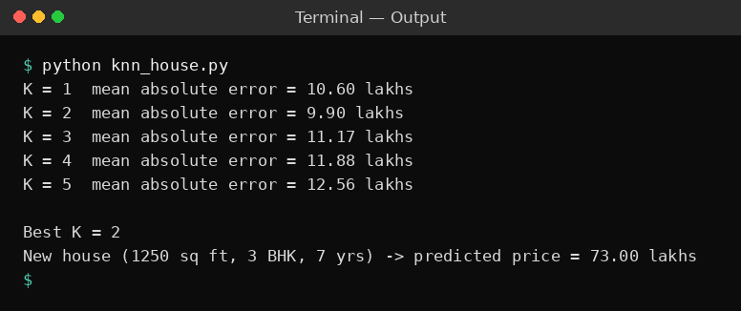
Result
The leave-one-out mean absolute error was 10.60, 9.90, 11.17, 11.88 and 12.56 lakhs for K = 1 to 5, so the best value is K = 2. With K = 2 the new house (1250 sq ft, 3 bedrooms, 7 years old) is predicted to cost 73.00 lakhs.
Problem 5: Customer Purchase Prediction
Aim
To implement a reusable KNN class with fit, proba and predict methods to predict whether a customer will buy a product, and to test it on a new customer.
Algorithm
- Load the data set and scale the features (standardisation or min-max) so that every feature contributes equally to the distance.
- Choose the number of neighbours K (a small odd number is preferred for classification).
- For a new sample x, compute the Euclidean distance d(x, t) = sqrt( sum of (x_i - t_i)^2 ) to every training sample t.
- Sort the distances in ascending order and select the K training samples with the smallest distances (the K nearest neighbours).
- Classification: count the class labels of the K neighbours and assign the class with the majority vote (the vote fraction gives the probability).
- Repeat steps 3 to 5 for every test sample and measure the performance (accuracy) for different values of K, using a test set or leave-one-out validation.
- Select the K that gives the best performance and use it to predict the output for a new sample.
Program:
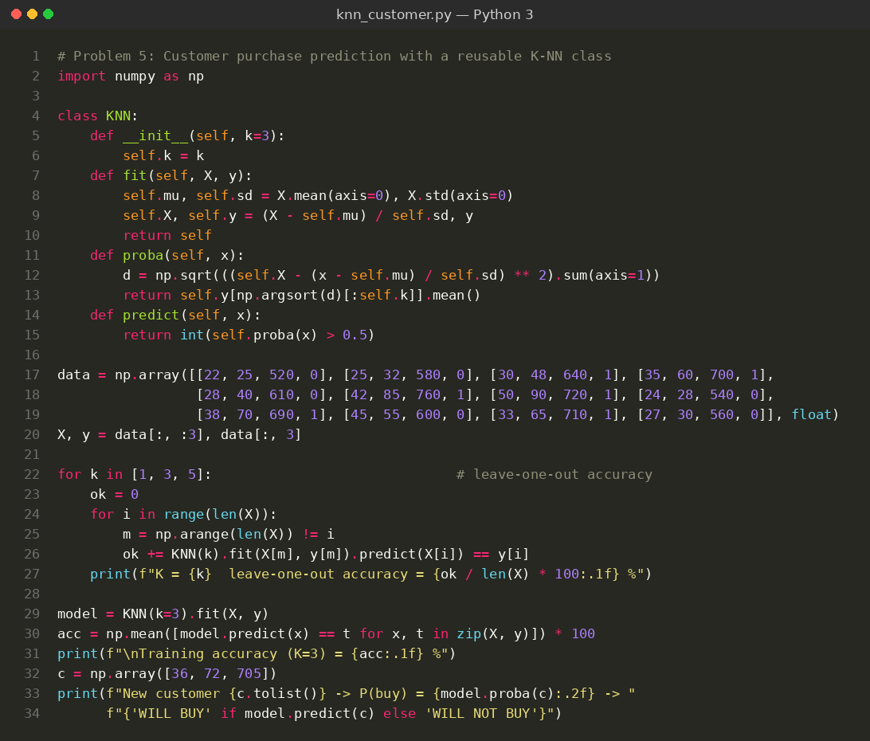
Input
Customer data set: 12 training examples with 3 inputs (Age, Salary in thousands, Credit Score) and the target Purchased (1 = Yes, 0 = No). Inputs are standardised inside the class and K = 3 is used. The new customer tested is (36 years, 72k, 705).
Age | Salary (k) | Credit Score | Purchased
22 | 25 | 520 | 0
25 | 32 | 580 | 0
30 | 48 | 640 | 1
35 | 60 | 700 | 1
28 | 40 | 610 | 0
42 | 85 | 760 | 1
50 | 90 | 720 | 1
24 | 28 | 540 | 0
38 | 70 | 690 | 1
45 | 55 | 600 | 0
33 | 65 | 710 | 1
27 | 30 | 560 | 0
Output
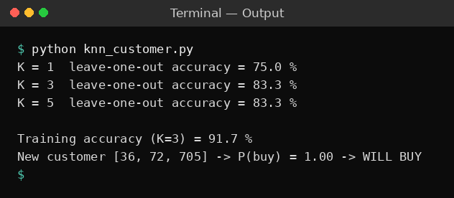
Result
The leave-one-out accuracy was 75 % for K = 1 and 83.3 % for K = 3 and K = 5. With K = 3 the training accuracy was 91.7 %. The new customer (36 years, salary 72k, credit score 705) has a purchase probability of 1.00 and is predicted to buy the product.

